 |  |  | 
 |  | 
 |  | 
 |  | 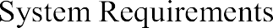
 |  | 
 |  | 
 |  | 
 |  | 
 |  | 
 |  | 
 |  | 

Introduction :
  - Smart parking is an advanced solution designed to reduce traffic congestion and save time by helping drivers quickly find available parking spaces. In busy cities, a large amount of time is wasted searching for parking, which increases fuel consumption and pollution. This system uses modern technologies like IoT, sensors, and machine learning to monitor parking spaces and predict future availability, making parking more efficient and user-friendly.
Problem Definition :
  - Finding parking in crowded areas is time-consuming and causes traffic congestion.
Drivers lack real-time information about available spaces.
This leads to fuel wastage and frustration.
The goal is to provide smart detection and prediction of parking vacancies.
Existing Systems :
  - Current systems include manual parking, ticket-based entry, and basic sensor-based solutions.
Some apps show availability but lack accurate real-time updates.
Most systems do not predict future parking availability.
They are often inefficient and not fully automated.

Proposed System:
- The system uses IoT sensors/cameras to detect parking occupancy in real time.
Machine learning algorithms predict future vacancy based on data.
Users can check availability and book slots via a mobile/web app.
It improves efficiency, reduces traffic, and saves time.

Literature Review
The system uses IoT sensors/cameras to detect parking occupancy in real time.
Machine learning algorithms predict future vacancy based on data.
Users can check availability and book slots via a mobile/web app.
It improves efficiency, reduces traffic, and saves time.

- System Requirements :
The system requires functionalities such as online appointment booking, department selection, date and time selection, and user data input. It should validate all required fields and provide confirmation after successful booking. Additionally, the system must be user-friendly, responsive, and capable of handling data efficiently.

Functional Requirements:

Detect whether a parking slot is occupied or vacant

Provide real-time parking availability to users

Predict future vacancy using historical data

Allow user registration, login, and slot booking

Provide navigation to the selected parking slot

Non-Functional Requirements:
• High accuracy in detection and prediction
• Fast system response time
• Scalability for large parking areas
• Secure handling of user data

2.1) Hardware & Software Requirements :

The system requires basic hardware such as a computer, laptop, or mobile device with an internet connection. On the software side, it uses

Hardware:

Sensors (ultrasonic/IR), cameras (optional), microcontroller (Arduino/Raspberry Pi), and internet connectivity are needed.
These components collect and transmit parking data.

Software:
Programming languages like Python/JavaScript are used.
Database systems like MySQL or MongoDB store data.
Frontend (React/HTML/CSS) and backend (Node.js/Django) handle user interaction and processing. 2.2) Software Requirements Specification (SRS) :
The system should accept user inputs such as name, phone number, email, department, date, and time. It must validate all inputs before submission and display available appointment slots. After booking, it should show a confirmation message. Future enhancements include backend integration for storing and managing data securely.

3.) System Design
The system is designed as a frontend-based application with a structured form interface. It follows a modular approach using
• Frontend-based system
• Form-based input design
• Responsive UI layout
• Modular structure (HTML, CSS, JS)
The design ensures responsiveness and usability across different devices, providing a smooth user experience.

3.1) UML Diagram
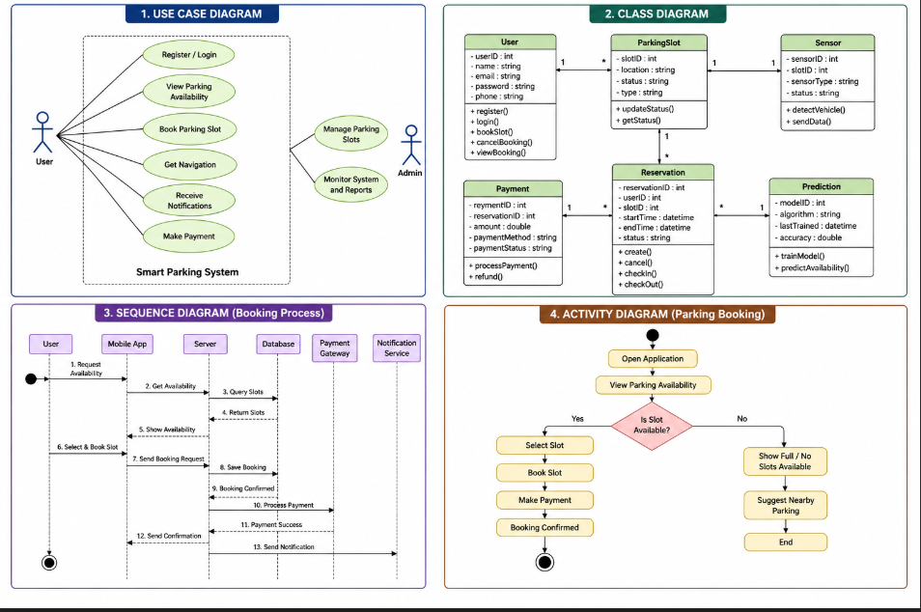
4) Implementation
The implementation of the system is done using
- HTML for structure
- CSS for styling (Flexbox & Grid)
- JavaScript for validation and interaction
- Responsive design for all devices

4.1) Sample Code
<!DOCTYPE html>
<html lang="en">
<head>
<meta charset="UTF-8">
<meta name="viewport" content="width=device-width, initial-scale=1.0">
<title>Smart Parking System</title>
<style>
body {
margin: 0;
font-family: Arial;
background: #f4f7fb;
}
header {
background: #1e293b;
color: white;
padding: 15px;
text-align: center;
} nav {
background: #334155;
display: flex;
justify-content: center;
gap: 10px;
padding: 10px;
}
nav button {
background: #2563eb;
color: white;
padding: 10px 15px;
border: none;
cursor: pointer;
border-radius: 5px;
}
.container {
padding: 20px;
}
.page {
display: none;
}
.page.active {
display: block;
}
cards {
display: flex;
gap: 20px;
flex-wrap: wrap;
}
.card {
background: white;
padding: 20px;
border-radius: 10px;
flex: 1 1 250px;
text-align: center;
box-shadow: 0 4px 10px rgba(0,0,0,0.1);
}
.grid {
display: grid;
grid-template-columns: repeat(auto-fill, minmax(80px, 1fr));
gap: 10px;
margin-top: 20px;
}
.slot {
padding: 15px;
border-radius: 8px;
text-align: center;
cursor: pointer;
}
.available {
background: #22c55e;
color: white;
}
.occupied {
background: #ef4444;
color: white;
} function update() {
renderGrid();
}
renderGrid();
</script>
</body>
</html>

4.2) Test Cases
TC ID | Module | Test Case Description | Test Steps | Expected Result | Status
TC-01 | User Registration | Register with valid details | Enter valid data → Click Register | Account created successfully | Pass
TC-02 | User Registration | Register with existing email | Enter existing email → Click Register | Error message displayed | Pass
TC-03 | User Login | Login with valid credentials | Enter valid email & password | Login successful | Pass
TC-04 | User Login | Login with invalid credentials | Enter wrong details | Error message shown | Pass
TC-05 | View Parking | Check parking availability | Open app → View availability | Slots displayed correctly | Pass
TC-06 | Search Parking | Search by location | Enter location → Click search | Parking list displayed | Pass
TC-07 | Slot Booking | Book available slot | Select slot → Confirm booking | Slot booked successfully | Pass
TC-08 | Slot Booking | Book already occupied slot | Select occupied slot | Error message shown | Pass
TC-09 | Payment | Successful payment | Enter valid payment details | Payment successful | Pass
TC-10 | Payment | Failed payment | Enter invalid payment details | Payment failed message | Pass
TC-11 | Prediction | View vacancy prediction | Select date/location | Prediction displayed | Pass
TC-12 | Navigation | Navigate to parking | Select slot → Navigate | Map opens with route | Pass
TC-13 | Notifications | Receive booking alert | Book slot | Notification received | Pass
TC-14 | Cancel Booking | Cancel booked slot | Select booking → Cancel | Booking cancelled | Pass
TC-15 | Admin Login | Admin access | Enter admin credentials | Admin login successful | Pass
Result:
The system successfully detects parking slot availability in real time.
Users can view, book, and navigate to parking spaces بسهولة.
The prediction module provides accurate insights into future parking availability.
Testing shows improved efficiency, reduced search time, and better resource utilization.
5.1) Output Screens

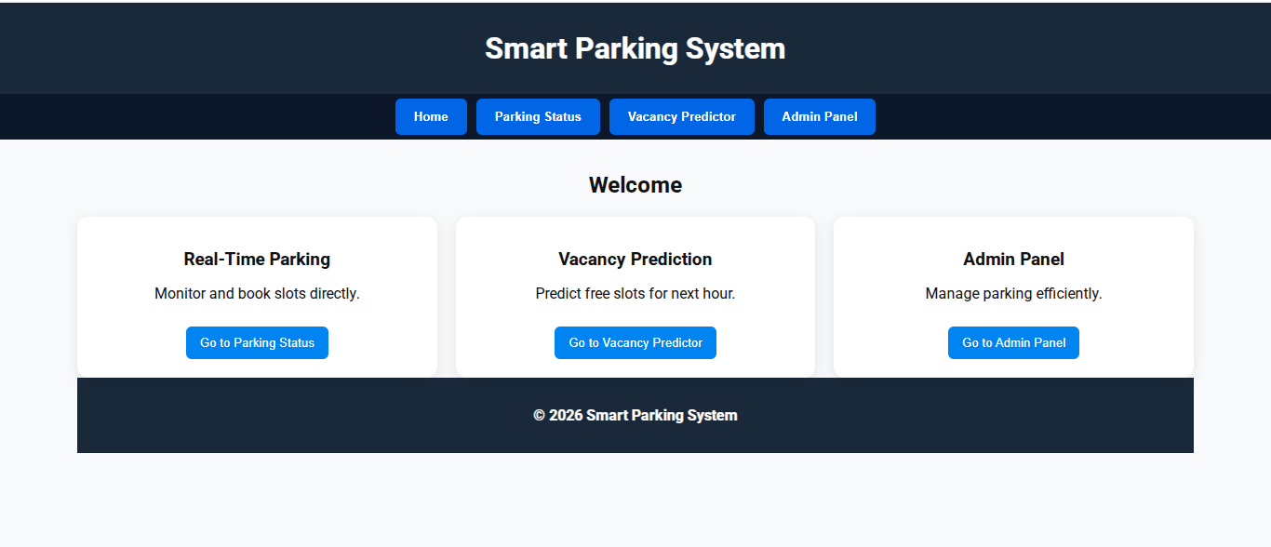
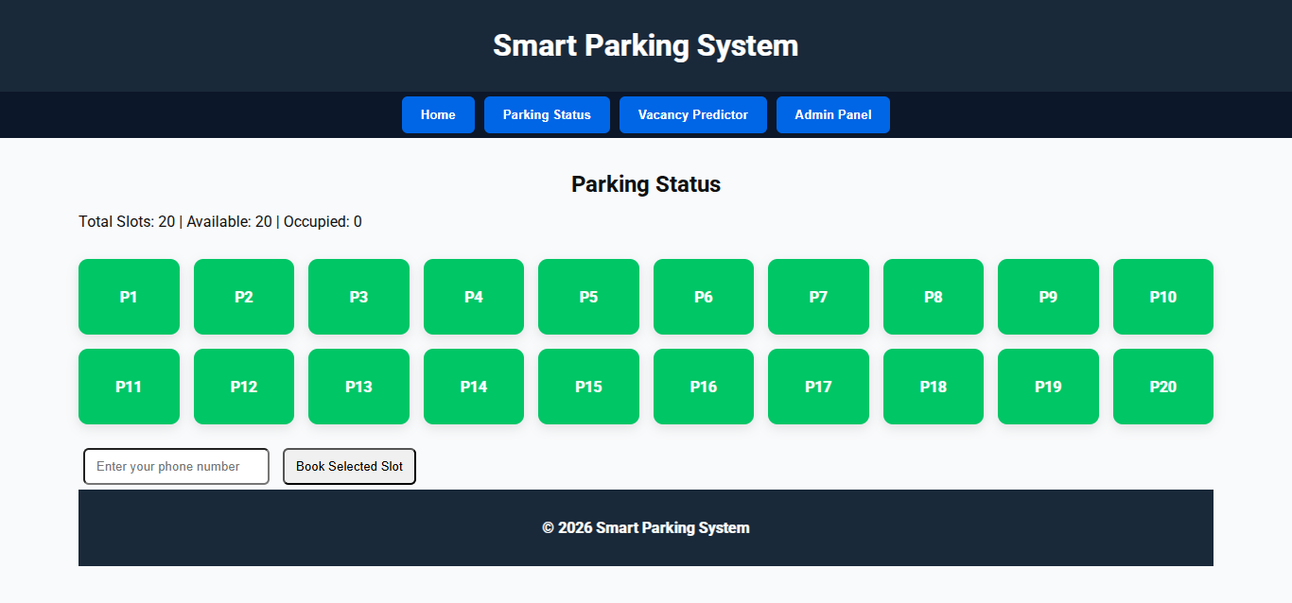
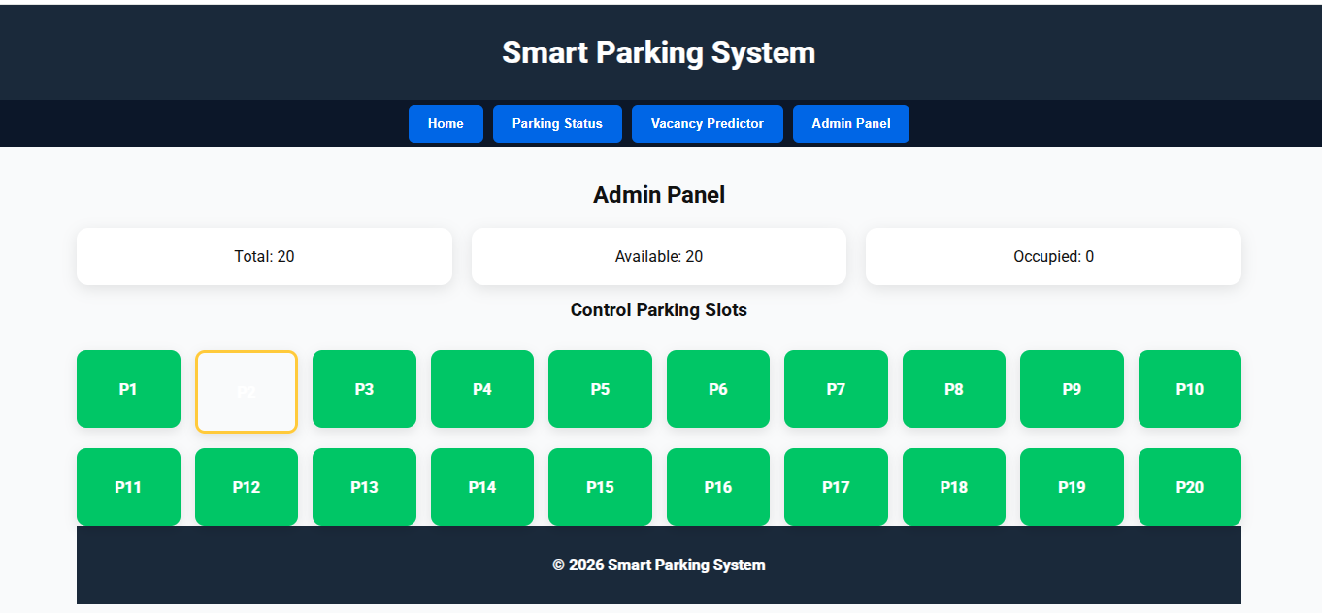

6) Conclusion
The system successfully detects parking slot availability in real time.
Users can view, book, and navigate to parking spaces بسهولة.
The prediction module provides accurate insights into future parking availability.
Testing shows improved efficiency, reduced search time, and better resource utilization.
References
- Research papers on Smart Parking Systems using IoT
- Studies on Machine Learning for prediction systems
- IEEE journals on intelligent transportation systems
- Online resources and documentation (IoT, Python, Node.js, React)
- Previous academic projects and case studies on parking management

